DORSET SCHOOLS’ A.A.
CROSS COUNTRY CHAMPIONSHIPS
King’s Park, Bournemouth
BH7 6JD
THURSDAY 16th January 2020

TIMETABLE
11.00am – 12.00pm COURSE OPEN FOR INSPECTION
1:00pm Year 7 Girls 2300m START 1x LONG-FINISH
1:15pm Year 7 Boys 3000m START 1x SHORT-1x LONG-FINISH
1:30pm Junior Boys 3900m START 2x SHORT-1x LONG -FINISH
1:45pm Junior Girls 3000m START 1x SHORT-1x LONG-FINISH
2:00pm Inter Boys 5400m START 1x SHORT-2x LONG-FINISH 2:20pm Inter Girls 3900m START 2x SHORT-1x LONG -FINISH 2:45pm Senior Girls 3900m START 2x SHORT-1x LONG-FINISH 2:45pm Senior Boys 6800m START 3x LONG-FINISH

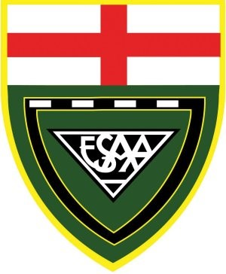

RACE HQ
REGISTRATION &
OFFICIALS AREA
OFFICIALS’
CAR PARK
ATHLETE & SPECTATOR ENTRY/EXIT TO STAND
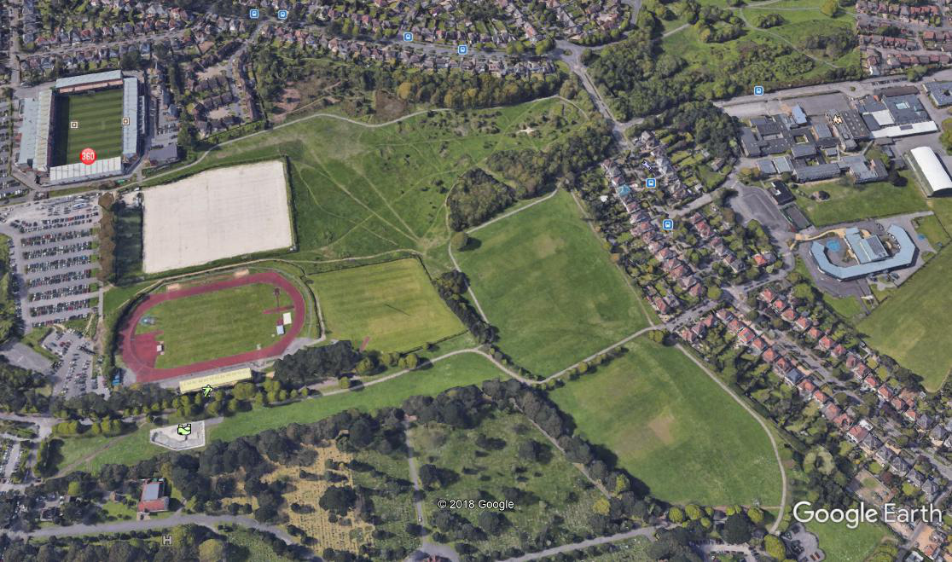
SHORT
LOOP
A-B-C-A
A
START
FINISH
B
C
LONG
LOOP
A-B-C-D-A

D
ORGANISING COUNTY
DORSET SCHOOLS’ A.A.
SPECTATORS’ CAR PARK

TEAM TENT AREA
WEATHER/UNDERFOOT CONDITIONS MAY LEAD TO COURSE CHANGES ON RACEDAY
RECOMMENDED FOOTWEAR – MAX 9mm SPIKES – THERE ARE SOME STONEY PATHS


